
CSI3105 Software Testing
Workshop 6: Introduction to pytest-mock testing
Tasks from this workshop must be completed. Some of these tasks will contribute to your ability to complete the Assessments.
Related to Learning Outcomes:
- Apply different test case design techniques, recognising the strength and weakness of each and being able to choose techniques appropriately.
Learning outcomes:
- To develop a basic understanding of how to use Mockito testing framework and to be able to write some simple mock test cases

This workshop covers:
- Basic Concepts associated with pytest-mock
- Writing simple mock test cases

What is pytest-mock?
pytest-mock is a plugin for the pytest unit testing framework in Python that simplifies the use of mocking objects. It provides a clean, Pythonic way to create mock objects and verify behaviour and interactions in your tests. Rather than just verifying state (e.g., checking return values using get methods), pytest-mock emphasises behaviour verification, such as ensuring that certain functions were called with expected arguments.
It builds on Python’s built-in unittest.mock library and introduces a convenient mocker fixture that makes mocking in tests more readable and less boilerplate-heavy.
pytest-mock is ideal for:
- Writing test cases
- Executing test cases
- Verifying behaviour and interactions between objects and functions
pytest-mock can be used within an IDE like PyCharm, where it integrates smoothly with the built-in testing tools. It can also be run from the command-line interface using pytest.

Part 0: Getting Started
- Get the workshop code from Canvas.
- Install pytest
  - File -> Settings -> Project: x -> Python Interpreter -> hit the + icon and search pytest -> install pytest
  - 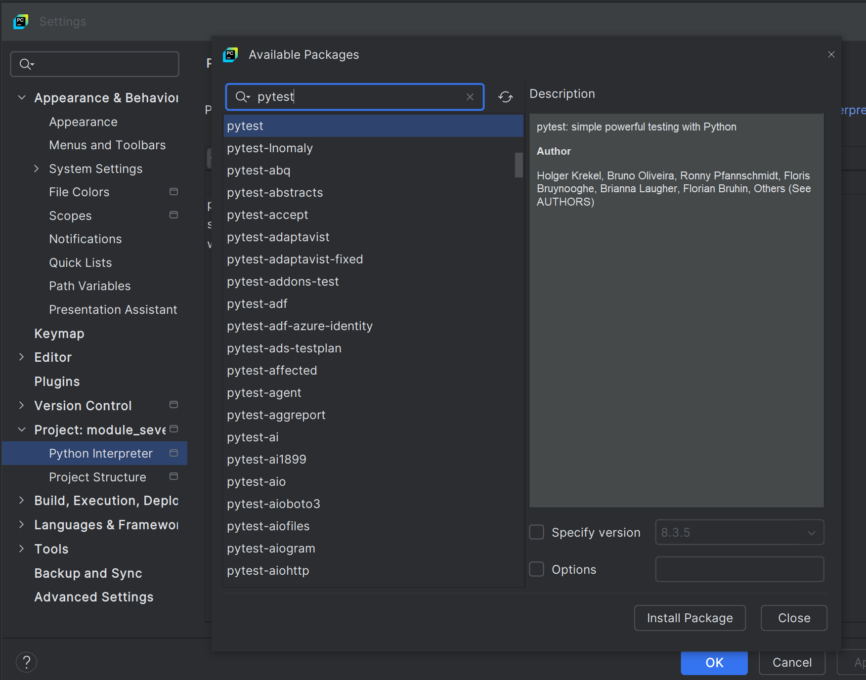
  - Repeat the above steps to install pytest-mock
  - 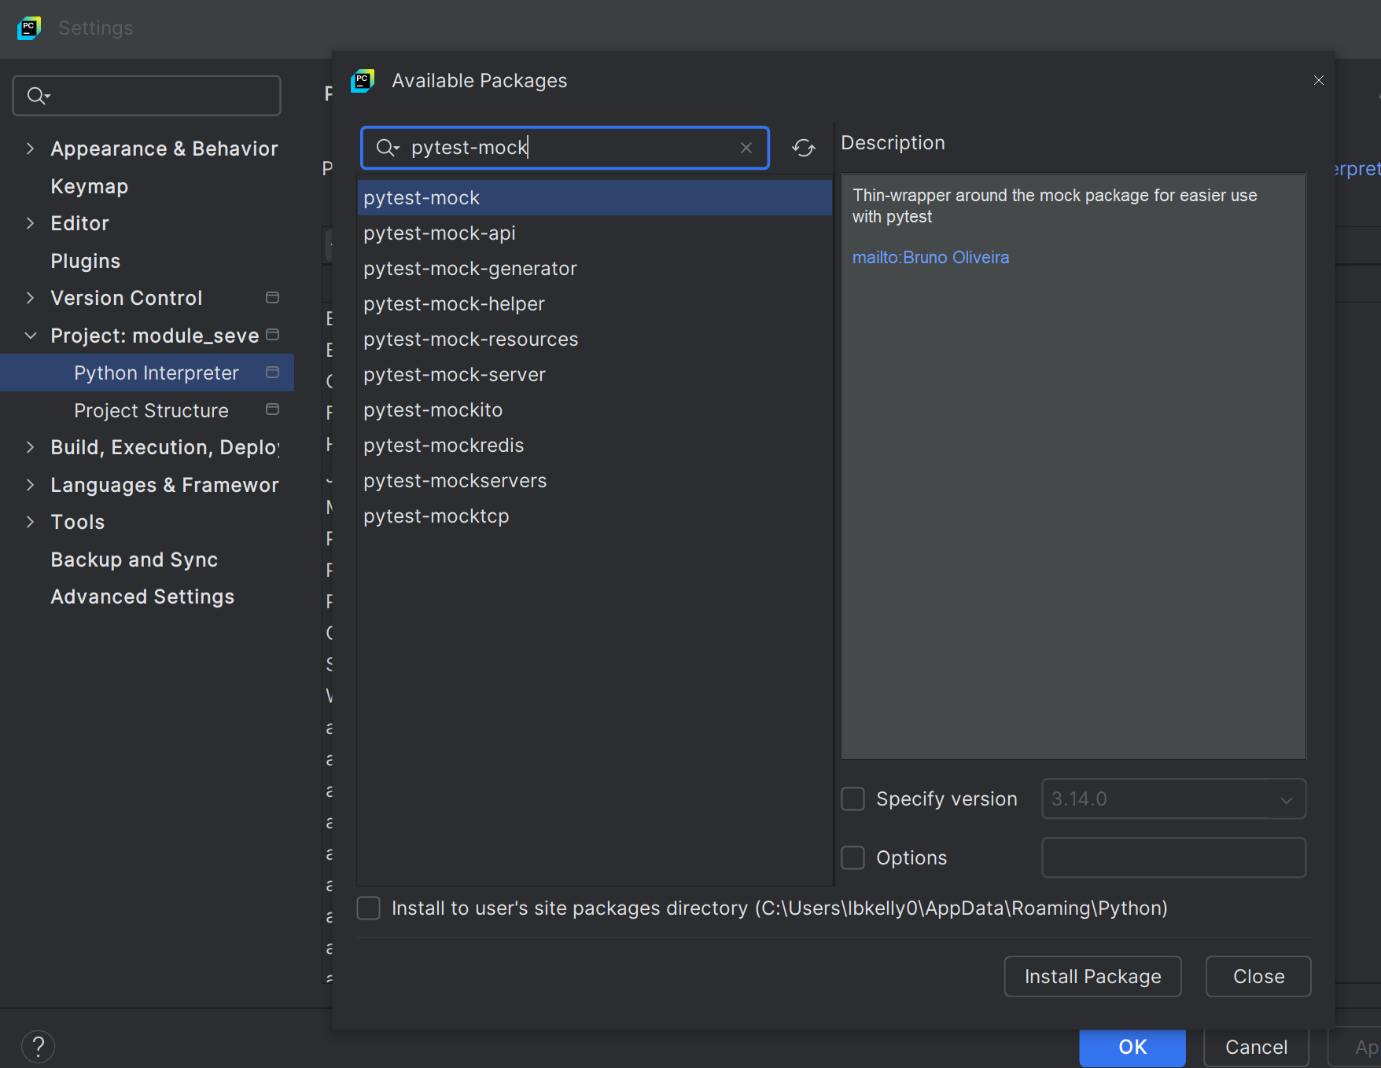
  - Ensure that module_seven is marked as sources root by right clicking the folder, going to mark directory as and select sources root.
  - Ensure that question_one, question_two, and question_three are python packages.
  - 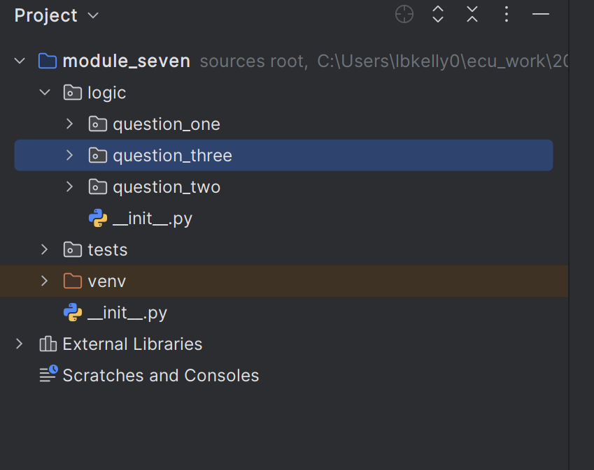

Question One: Basic Mocking
Code: Found in module_seven.logic.question_one
Scenario: Class A depends on Class B, but B is not yet implemented. This is a common case during development when you want to begin testing Class A without waiting for B to be completed. In the true spirit of unit testing, we would want to test Class A, as soon as its developed, in insolation from Class B.
Code Task:
- Understand what is going on with the test case in tests.test_questions_one.test_class_a.py
  - 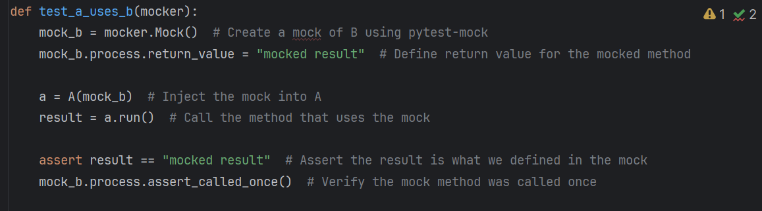
- Fill in the missing code to complete the function
  - “def test_a_uses_b_deny_access(mocker):”
  - This test case tests the method “do_not_run” from class A, which uses the unfinished implementation “deny_access” from class B.
Testing Theory: Unit tests are designed to test each component in isolation. When a class depends on another that is unfinished or unreliable (e.g. it accesses an API or performs file I/O), mocking allows us to simulate that dependency’s behaviour and focus solely on the logic of the unit under test.
Questions:
- Why is it important to test Class A in isolation rather than waiting for Class B to be implemented?
- What would happen if you wrote a unit test for Class A without mocking Class B? What type of error or limitation might you encounter?
- How does mocking help ensure that a unit test only fails when there’s a fault in the class being tested (and not in its dependencies)?

Part 2: Monkeypatching & User Input
Code: Found in module_seven.logic.question_two
Scenario: You are creating a DatabaseConnector that configures itself using user input. An additional *problem* is that the database doesn’t exist yet. You want to test this logic, but without requiring actual keyboard input or a real database connection. In this scenario, we are mocking the database. We are then further monkey patching the user input.
Code Task:
- Understand what is going on with the test case in “tests/test_question_two/test_database_connector.py”
- Change the monkey patch in the pyfixture on line 8 to not patch “builtins.input” but to patch the actual method “from_user_input”.

Testing Theory: When code involves external interaction (e.g. input(), print(), file access, environment variables), we treat these as side effects. Unit testing code with side effects often involves monkeypatching, which temporarily overrides built-in behaviour to simulate a consistent environment for testing. In your case study you will need to provide user input. Monkey patching is great for this instance.
Questions:
- Why should we avoid using input() directly in our unit tests, and how does monkeypatching help?
- What would happen if you didn’t patch the input() function in this test?

Part 3: Mocking & Scaffolding a Complex Service
Code: Found in module_seven.logic.question_three
Scenario: You are developing a ReportGenerator class that depends on two services: a DataFetcher (calls an external API) and a Formatter. These dependencies may not be implemented yet (they are not) or may involve unpredictable behaviours. Ultimately, we are preforming unit testing, so we want to test the ReportGenerator class in isolation.
Code Task:
- Understand what is going on with the test case in tests.test_questions_three.test_report_generator.py
  - Break the test, by commenting out a mock, then see what happens.
- We are now wanting to test the integration between Formatter.py and ReportGenerator.py, write a new test case that mocks DataFetcher, but tests the integration between Formatter and ReportGenerator.
Testing Theory: Mocking is essential when your system grows in complexity. Instead of relying on real components (which can introduce slowness, or nondeterminism), you use mock objects or scaffolding to simulate behaviour in a predictable way. This lets you write robust unit tests that still verify interaction between components.
Questions:
- Why is it important to mock both the DataFetcher and Formatter when testing the ReportGenerator?
- How does this allow you to verify interactions between components without testing the internals of each one?
- What role do fixtures play in organizing and reusing mocks? How does this improve test readability and maintainability?
- At what point would you move beyond mocking to write integration or system level tests for this reporting system?

